Team Report for IoT Project 1

Project Title
Weather Station with a focus on Rain Detection and user alerting when rain stops.

Project Members
Name | Email
Ahmad Din | S00287223@atu.ie
Arif Taha | S00292948@atu.ie
Joshua Jameson | S00291620@atu.ie
Paschal Okolo | S00292948@atu.ie

Table of Contents
Project Links 3
Data Gathered & Analysis 4
Problems 4
Different Sensor Readings 4
Invalid Temperature Readings 5
Slow Code without the OLED connected 5
Night Sensor Mode 5
List of the requirements 6
Initial design 6
How you plan to store and manage data 11
Test table for each requirement 11
Sustainable Development Plan 12
Future improvement planned 12
Advanced Hardware and Durability Improvements 12
Intelligence and Software Optimizations 13
Implementation plan 13
Equipment needed and Parts List: 13
Core Detection Logic 13
Thing Speak API Storage 13
Smart Alert Logic 14
Final Implementation Steps 14
Link to code: 14
APIs: 14
Screenshots/ Photos/Diagram 15
Security Concerns: 17
Testing Approach: 17
Hardware Testing plan: 19
Summary of Project: 20
Project Report: IoT Rainfall Detection System 20
References 22

Project Links
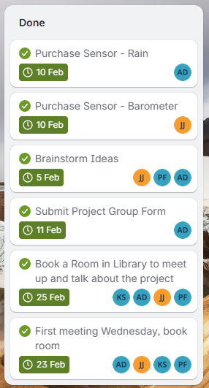
Trello: IoT Project 1 | Trello
Our team used Trello to organize the objectives we needed to do. It was also a good tool to brainstorm together and delegate tasks to people before we even had our first meeting in the library.
Trello (Task Tracking): Manages the project lifecycle. We use it to track milestones such as Sensor Calibration Complete or API Integration Tested.

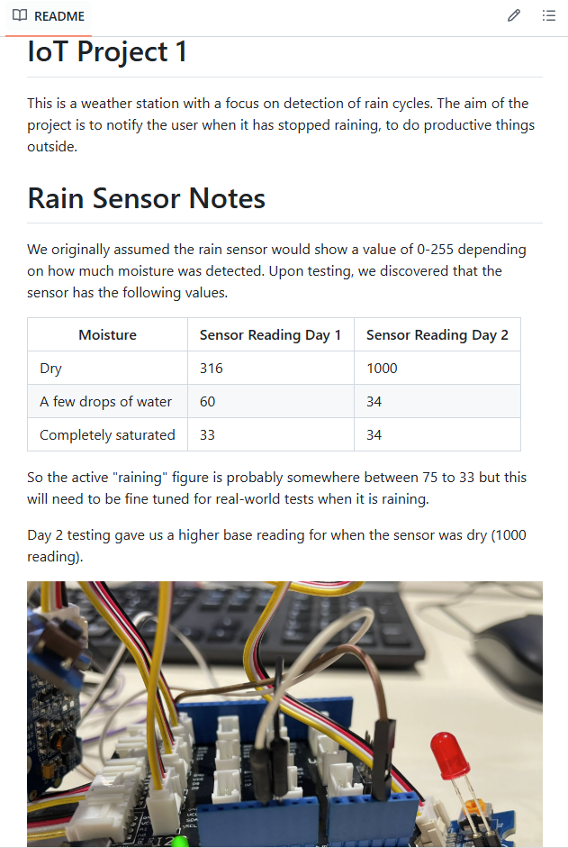
GitHub Team Page: JKJameson/IoT-Project-1
Github is an excellent resource that allows us to work as a team with version history. We can see who what did as well as have a historical backup of any previous code that we may have changed our mind and wanted to reference or restore back to the way it was before.
GitHub supports MD (Markdown syntax) for readme files, allowing for a rich-text style format for text notes (Cone, 2026). We made use of this in our readme with headings, tables and image resources.
GitHub (Code & Docs): Stores your .ino source code, README documentation, and circuit diagrams. This ensures that every change to the logic is tracked and version controlled.

Data Gathered & Analysis

We originally assumed the rain sensor would show a value of 0-255 depending on how much moisture was detected. Upon testing, we discovered that the sensor has the following values.

We found an example of how to detect rain using the sensor that we purchased.
Link: Rain Detection System Using Arduino | Arduino Project Hub

The example was very basic and didn’t provide enough useful information for us to successfully use the sensor without our own experimentation.

The sensor we purchased has a Digital and Analog output.
- If we use the digital output, it provides a LOW and HIGH value based on pre-determined values. While the value can be changed with the built-in potentiometer, this is not very useful for us because it doesn’t provide a way to detect sensitive variations in rain fall, such as the gradual decrease in rain.
- The analog output is much more useful; the analog value varies accurately based on how much water is currently in contact with the sensor. As the rain runs off, it will result in a lower value which could still be measured as a sustained but low amount of rain.

Our sensor readings were not the same as the example we found (linked above).
Moisture | Sensor Reading Day 1 | Sensor Reading Day 2
Dry | 316 | 1000
A few drops of water | 60 | 34
Completely saturated | 33 | 34

Problems

Different Sensor Readings
We discovered that the sensor did provide different reading ranges on the two days we setup the prototype. This will require further investigation, because it would affect our threshold values that we need to set in code to detect rain fall based on the sensor value at any given time.
So, the active "raining" figure is probably somewhere between 75 to 33, but this will need to be fine-tuned for real-world tests when it is raining.
Day 2 testing gave us a higher base reading for when the sensor was dry (1000 reading).

Invalid Temperature Readings
The Grove example code for the temperature sensor: Grove - Temperature Sensor V1.2
We encountered an issue with the temperature sensor during the project. To solve it, we researched the sensor on the Grove website and used the provided sample code. However, the code did not work because it was written for version 1.2 of the temperature sensor, while the sensor we were using was version 1.3.
In the original code, the constant value was:
const int B = 4275000;
After identifying the version mismatch, we modified the constant value to:
const int B = 3950;
Once we updated the value of B, the temperature sensor worked correctly.

Slow Code without the OLED connected
Testing carried out on Tuesday 3rd March 2026. Finding on project Loop was slower to output readings without OLED connected to Arduino. We believe this is because the library waits for the screen to respond with a timeout, but because the screen is not present, it always times out in the loop, taking about 5 seconds for a single loop to update.

Night Sensor Mode
We want to add a feature that detects a rise in brightness. If it stops raining with a rise in brightness (measured from a rolling average) then it could be a signal that the rain has not just slowed down or stopped, but the weather has cleared up too. In other words, the rain clouds may have moved on.
This is an advanced code that we still need to implement.
We need to account for Daylight & Nighttime using a minimum daylight sensor value.
If the device is placed near street lighting, we need to provide a way to adjust the nighttime sensitivity value, perhaps with a potentiometer.

List of the requirements
Functional Requirements:
- The system must detect rainfall using rain sensor.
- The system must detect when rainfall has stopped without being manually wiped.
- The system must measure temperature by using an analog or digital temperature sensor.
- The Arduino must process sensor data.
- The system must send a notification when the rain is detected.
- The system must send a notification when it detects that rain has stopped.
- The system should have different modes to change what events to be notified about.
- The sensor must read values and convert them to usable values. For example degrees Celsius for temperature and and Lux for light.
- The system must include an ON/OFF switch.
- The code should be optimal to prevent an unnecessary drain of energy.
Hardware Requirements:
- Arduino Kit
- Rain sensor
- Rain resister module
- Light sensor
- Temperature sensor
- Jumper wires
- Power Supply

Initial design
- Project Overview:
This project is an IoT-based Rainfall Detection System designed to detect rainfall and environmental conditions in real time.
We are using rain sensitive water sensor and provides:
- Realtime Rain Detection.
- Realtime OLED displays feedback (if it's raining it shows it is rain)
- Led alert (a placeholder for a buzzer that can be enabled / disabled).
- Temperature monitoring. (to Celsius).
- Ambient light monitoring (to Lux).
The device will be in an enclosed box in a protective container to allow safe outdoor use and contribute to early weather alert.
- Proposed Device Design (Sketch Explanation):
Main Container contains:
- Sensors
- Arduino kit
- Power Supply
- Protects circuitry from moisture and dust
- OLed is on the outside
- Light sensor on top of the lid
Small Container contains:
- Rainfall Sensor on top on angle
- Inside Temperature
Oled Screen shows:
- Rain status (Not raining/ raining)
- Temperature readings from surrounding
- Light level (Dark/ light)

Example:
It is raining.
Temp 20.0C
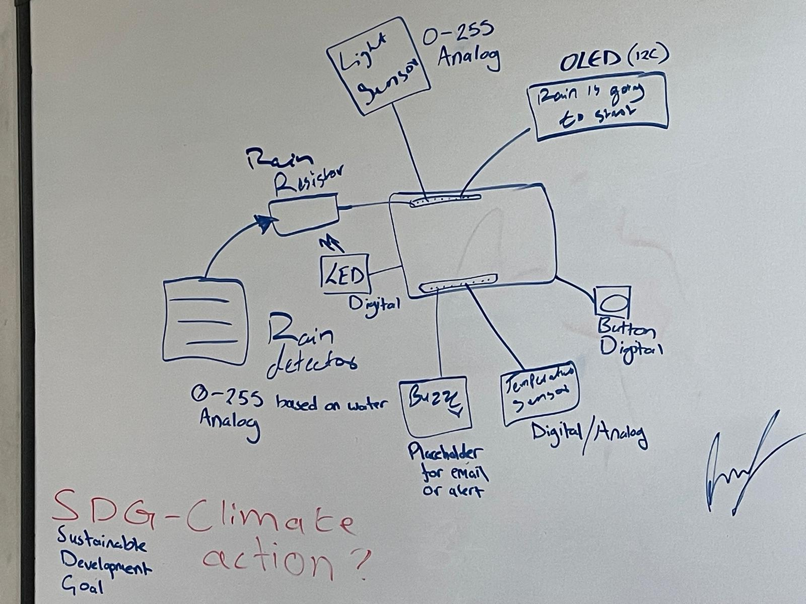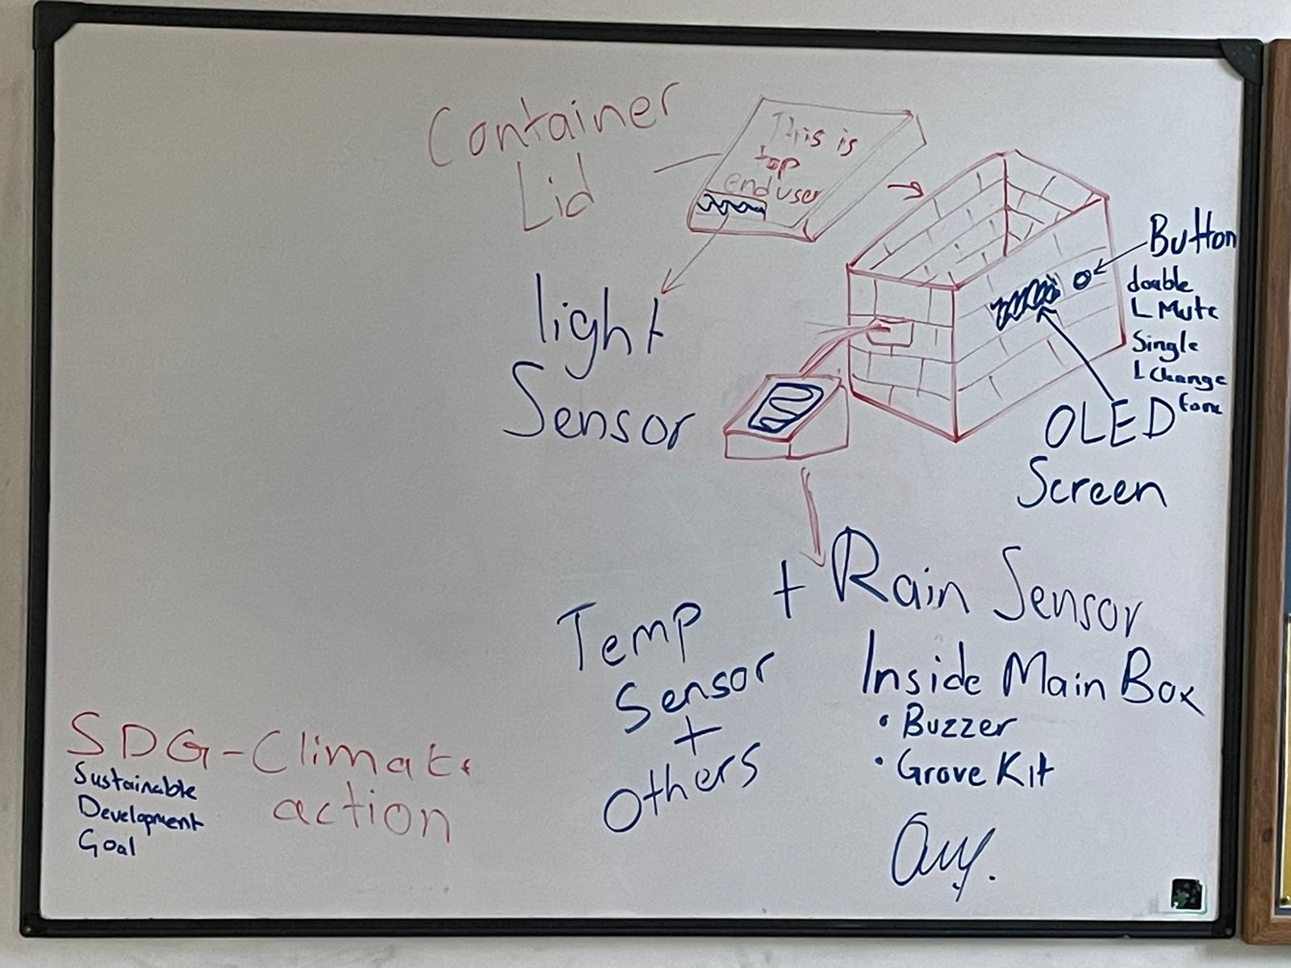

Proposed code design:
View Source Code

Proposed hardware setup:
Component | Function | Connection Type
Rain sensor | Detects Water | Analog
Light sensor | Measures brightness | Analog
Temperature | Measure Temperature | Analog/ Digital
LED Module | Visual Alert | Digital
Buzzer | Audible Alert | Digital
OLED Display | Display Output | 12C
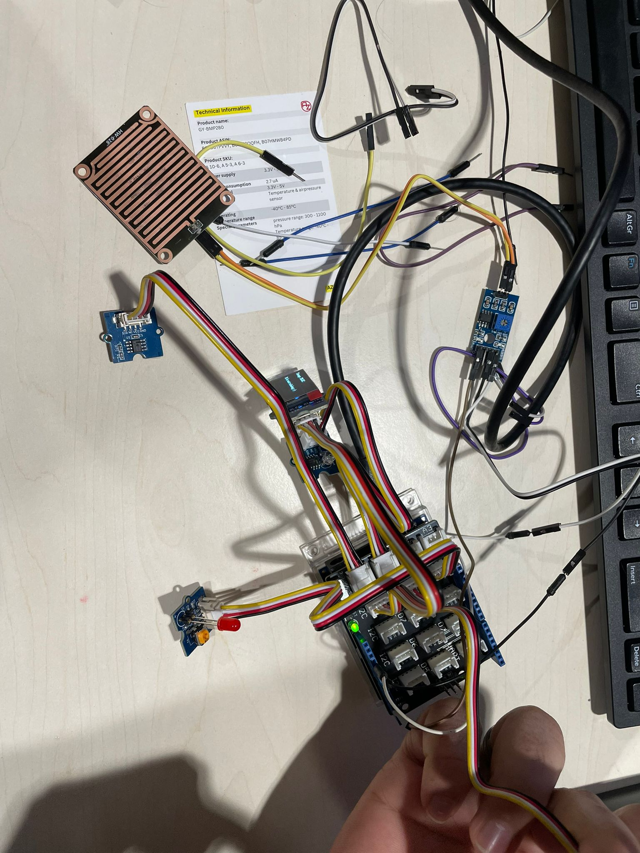
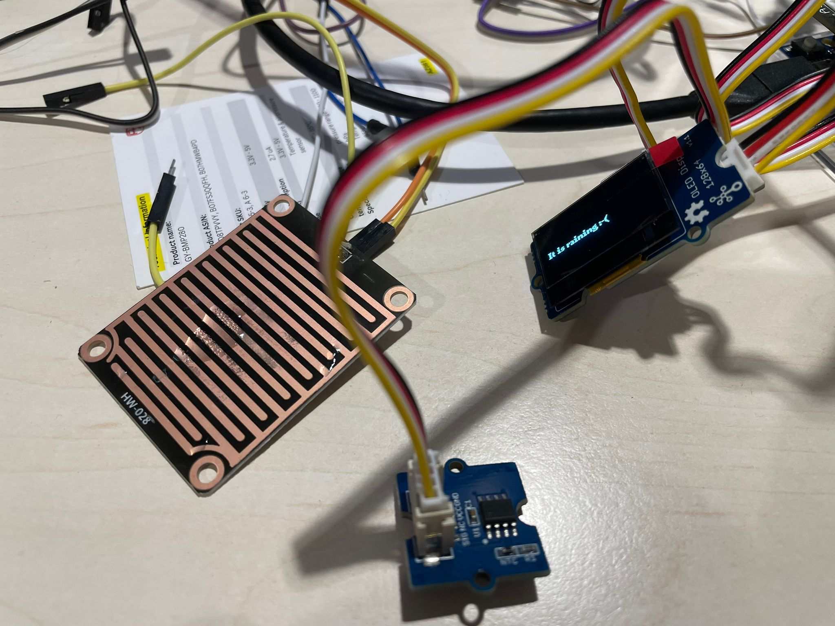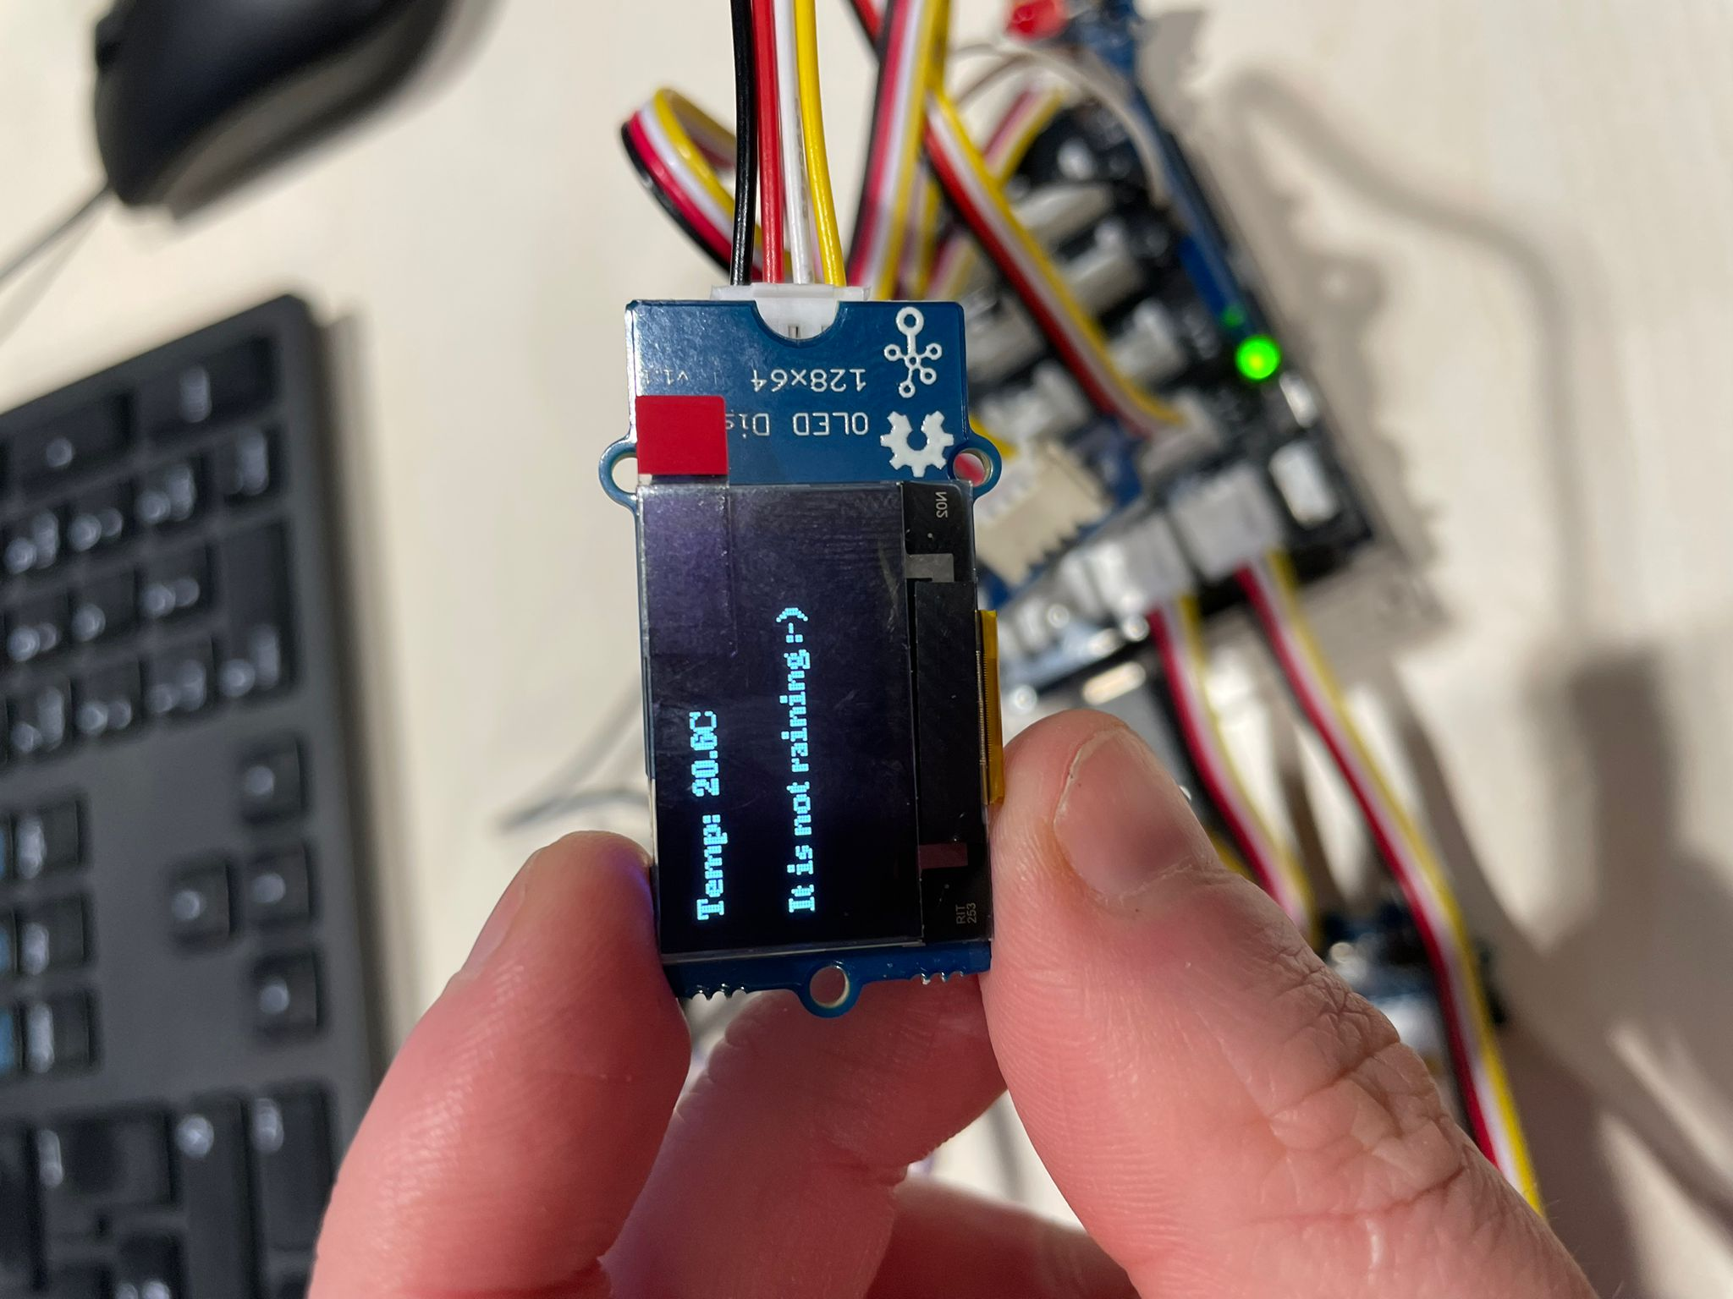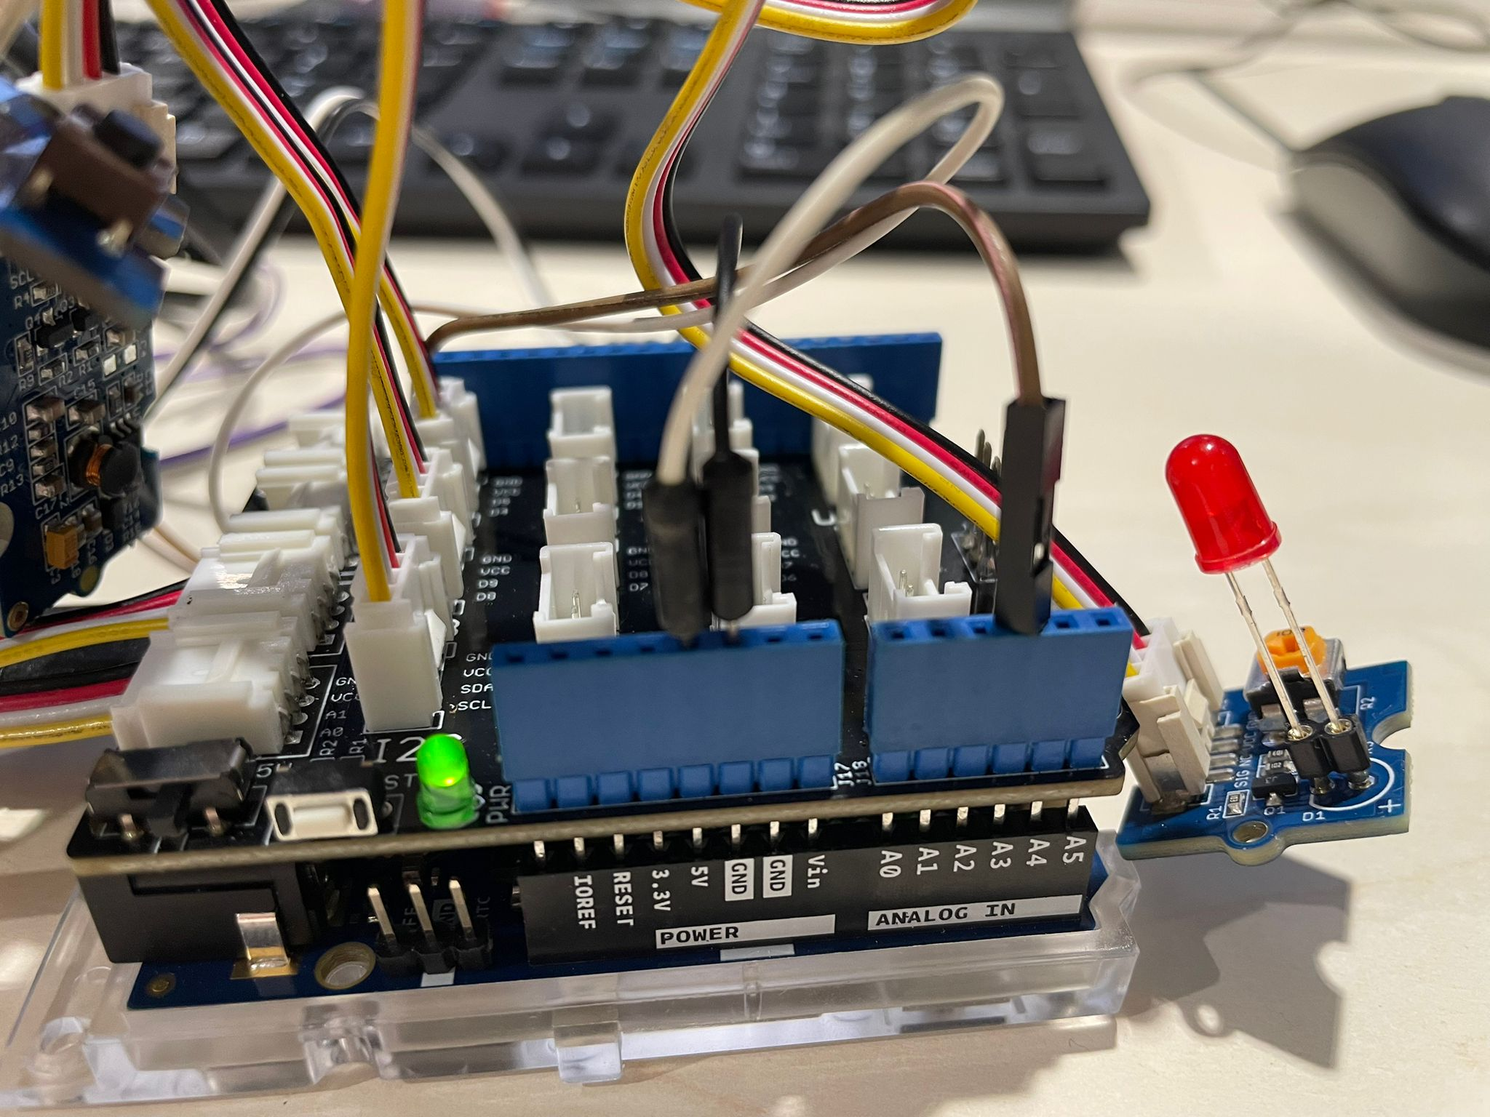

How you plan to store and manage data
Data Generated & Processing
- Sensor Data: The system generates Analog Signals (0–1023) from the HW-028 rain sensor and Temperature Readings from the Grove sensor. Conversion to standardized units is required.
- Logical Data: The microcontroller processes raw input into "States" (e.g., "It is raining" or "Not raining") based on calibrated thresholds.
APIs Used
- Used as the primary IoT cloud for live data logging and generating visual trend charts.
- Triggers instant mobile notifications when "Heavy Rain" thresholds are met.
- The Blynk app needs to access the data from the Arduino, processed by Pushing Box.
Data Storage & Management
- Pushing Box: We will implement the pushing box using the URL ingestion to store values of the Arduino sensor in order to see the data with historical tracking. We intent to record all the useful information from the weather station in order to provide a good UX via the app as well as possibly adding historical graphs if our project time allows for it.
- Blynk App: We will use the Blynk app to interface with our device and turn the raw data into a good user experience. Device data is not going to be stored in the Blynk app, but it will act as a bridge to interface with the data.

Test table for each requirement
Test case Title | Test Steps | Test Data/ screenshot | Expected result | Test Pass/ Fail | Tester | Date
1 - Display Rain Status (Requirement 1) | Pour rain on the sensor, does it show it is raining? |  | Screen shows it is raining. | PASS | Group | 19th Feb 2026
2 – Display no rain status  (Requirement 2) | Allow the rain sensor to clear from gravity. |  | Screen shows it is no longer raining. | PASS | Group | 26th Feb 2026
3 – Show Temp | Touch the temp sensor to warm it up. |  | The temp raises to a warm hand temp. | PASS | Group | 26^{h} Feb 2026

Sustainable Development Plan
The SDG goal that we have targeted is “Life on Land”, specifically the potential to reduce the overwatering of plants when it has been raining. This would have the potential to stop water wastage and prevent nutrients from being washed out of the soil.
We may have a lot of water in Ireland, but it’s still a valuable resource, especially due to the need to treat the water before consumption.
It could also help during droughts, when farmers may assume that their crops need watering, but instead it rained without them noticing or being able to pause their automatic watering system that does not consider precipitation that happened that day.

Future improvement planned
The following outlines future improvements and next steps to better align the project with the SDG – Climate Action goals shown in the design sketch.

Advanced Hardware and Durability Improvements
- To operate effectively in real-world climate conditions, the system must be built to withstand outdoor environments.
- Corrosion-Resistant Sensing:
The current copper-trace rain sensor should be replaced with a capacitive rain sensor. Unlike exposed metal sensors, capacitive models do not oxidize over time, ensuring improved durability and long-term accuracy.
- Solar Power Integration:
Incorporating a 5V solar panel alongside a Li-Po battery charging module (such as the TP4056) will allow the main unit to function independently outdoors without requiring a USB power connection. This supports continuous, sustainable operations.
- Acoustic Rain Measurement:
A piezoelectric vibration sensor can be added to detect raindrop impacts on the enclosure. By analyzing vibration patterns and frequency, the system can differentiate between light rainfall and heavy storms, increasing measurement precision.

Intelligence and Software Optimizations
- Future software enhancements should focus on improving system intelligence and usability.
- Implementing a lightweight machine learning model will allow the system to identify and filter false positives. This prevents alerts caused by morning dew, debris, or animals triggering the sensor.
- Interrupt-Driven Button Interface:
The user interface can be refined using interrupt-based programming:
- Single press: Switch between Celsius and Fahrenheit.
- Double press: Temporarily mute the buzzer for 30 minutes during heavy rainfall.
- Long press: Reset the daily rainfall total.
- Deep Sleep Mode:
Programming the ESP32 or Arduino to enter a low-power deep sleep state will significantly extend battery life. The device will only wake up when moisture is detected, making it energy efficient for long-term outdoor deployment.

Implementation plan

Equipment needed and Parts List:
- Arduino Kit: Serves as the central microcontroller to process sensor data.
- Power Cable: To give power supply.
- Rain Sensor: Connected to Analog pin A3 to detect moisture levels.
- OLED displays: Connected via the I2C port to show real-time status messages.
- Temperature Sensor: Connected to Analog pin A0 to monitor ambient climate.
- light Sensor: Connected to Analog pin A1 to distinguish between day and night.
- Main Box: A waterproof housing to protect the Arduino and wiring from the rain.
- Box Lid: A surface to mount the rain sensor at a slight angle for water runoff.
- Code Samples

Core Detection Logic
This snippet is based on your project1.ino. It handles the local reading of your sensors and updates the OLED display.

Thing Speak API Storage
To store your data in the cloud (for the Data Management part of your plan), add this logic. You will need a Wi-Fi-capable board (like an ESP32) or a Wi-Fi shield for your Uno.

Smart Alert Logic
Use the code to trigger a phone notification when it starts raining.

Final Implementation Steps
- Test the RAIN_SENSOR_MIN value (600) with a wet sponge to ensure it triggers correctly.
- Mount Rain sensor outside at a 45° angle.
- Use Trello to log any errors you find during testing and GitHub to commit your final code updates.

Link to code:
Source Code

APIs:
For SDG-Climate Action and the current code in GitHub repository, the following APIs are planned for integration to move your data from the local Arduino to a global monitoring platform:
API (Data Logging & Visualization)
- Purpose: This is the primary "storage" API. It will receive the temperature, rain Val, and light Val variables calculated in your loop () function.
- Data Management: It transforms your raw sensor data into live, public-facing graphs that track climate trends over time.
- Implementation: You will use an API Write Key to send data via an HTTP GET request whenever the rain status changes.
- We will use Pushing Box to process the data from the Arduino.

Screenshots/ Photos/Diagram



Security Concerns:
Over the course of the project, we deduced that during the transmission of data from the rain sensor to the user's phone, there could be the risk of fabrication of data. An individual with plans of stealing rain sensor data and sending false reports could break into the system.
A possible solution that we came up with was data encryption (HTTP to HTTPS) to name an example. By doing this we could prevent man in the middle attacks as well as interception.
We could also create anomaly detecting code to detect abnormal changes in the readings, for example sudden spikes in temperature reading. This could be done by adding a range of validators that would reject fictitious readings (temperatures of over 200 degrees).
We could also include timestamps when sending over data to prevent attackers from sending over once validated readings.
A lesser security threat could be simple eavesdropping whereby attackers do not tamper with data but monitor and record it. This could allow attackers to pinpoint end users' locations and sell that information. This can be prevented simply by using a secure Wi-Fi connection such as a WPA3 connection with a strong password. This problem can also be solved through end-to-end encryption in the Arduino IDE code. Such an example being;

Encrypted_Data = AES (data, device_secret_key)
Send (Encrypted_Data)

There could also arise the problem of route hijacking whereby data is diverted to other unknown ends. This could be handled by using VPN tunnels instead of relying on open routing. This would ensure that data is protected even though routing changes.

Testing Approach:

Testing the project is important because we must ensure that all the information is correct, the system delivers the expected outcomes, and it displays updates correctly when raindrops are detected.
Software Testing plan:
We ran the code to test the program before connecting the real sensors. We also tested how the program reacted when the rain signal was detected (result: turns light on and displays message). The testing verified that temperature values display correctly on the screen according to the code.
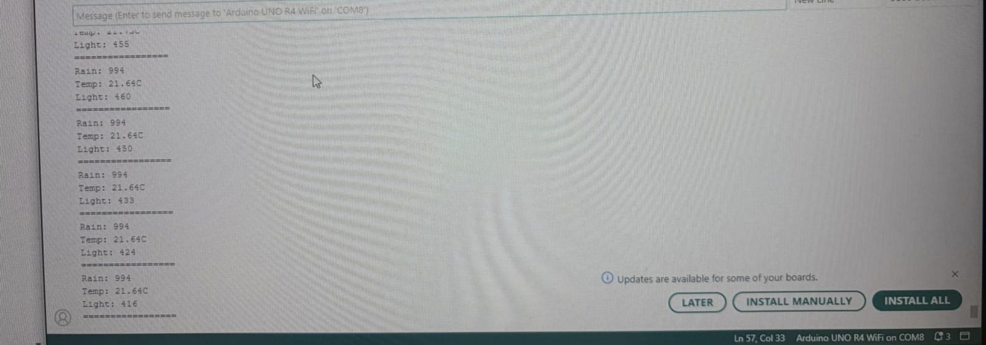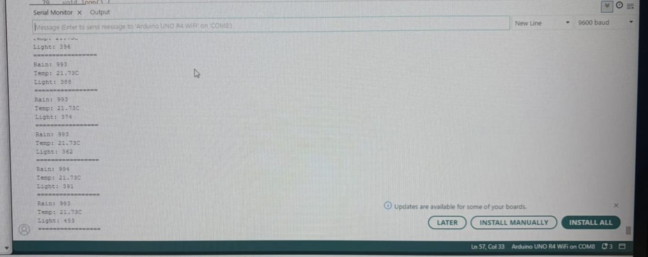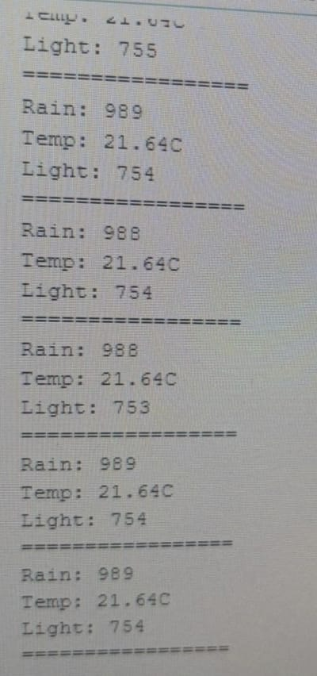
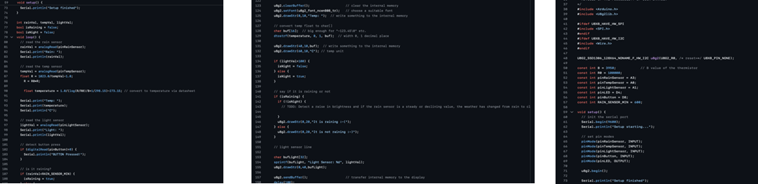

Hardware Testing plan:
We verified that the physical components used for the project work produce expected results. The rain sensor detector successfully detects drops by dropping water on it. We checked that the light display works when connected to the Arduino and functions with the rain sensor because the light turns on when there is no drop on the rain sensor.
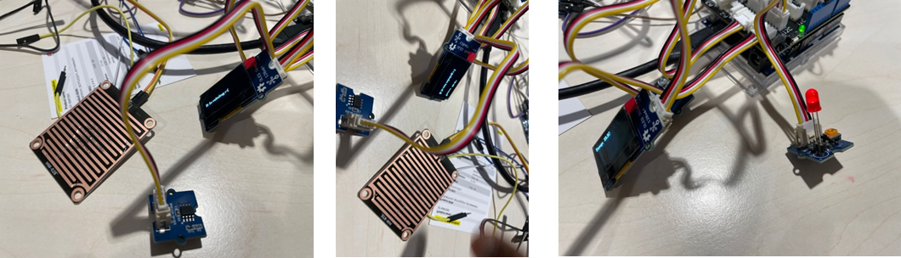

Summary of Project:

Project Report: IoT Rainfall Detection System
Project Title: Rain Detector
Team Members: Ahmad Din, Arif Taha, Joshua Jameson, Paschal Okolo
Repository: JKJameson/IoT-Project-1
Trello: IoT Project 1 | Trello
Demo: Video for Demo project working

1. Summary:
The Rain Detector is an IoT-based environmental monitoring system designed to detect rainfall and track real-time weather conditions. By integrating moisture, temperature, and light sensors with an Arduino microcontroller, the device provides immediate feedback via an OLED display and visual alerts. The project aims to contribute to early weather alerts and align with Sustainable Development Goals (SDG) for Climate Action.

2. System Requirements and Hardware:
The system was developed based on a set of core functional and hardware requirements to ensure reliable environmental sensing.
- Functional Requirements: The system must detect rainfall, measure ambient temperature, process sensor data via Arduino, and provide notifications upon rain detection.
- Hardware Components: The core kit includes an Arduino microcontroller, a HW-028 rain sensor, a Grove temperature sensor, a light sensor, and an OLED display for output.
- Visual and Audible Feedback: An LED module provides a visual alert, while a buzzer is integrated for audible notifications.

3. Technical Implementation and Data Analysis:
The project utilizes a pipeline to convert raw physical signals into digital insights.
- Sensor Calibration: Initial testing showed that the analog output of the rain sensor is superior to the digital output for detecting sensitive variations in rainfall. While a dry sensor produced readings up to 1000, a completely saturated sensor dropped to values as low as 33-34.
- Data Management: Raw signals (0–1023) are processed into states such as "It is raining" or "Not raining".
- Control: GitHub is utilized to manage source code (.ino files), README documentation, and circuit diagrams, ensuring all logic changes are tracked.

4. Challenges and Problem Solving:
During development, the team successfully navigated several technical hurdles:
- Sensor Version Mismatch: The temperature sensor initially failed because the provided sample code was for version 1.2, while the hardware was version 1.3. The team identified the issue and updated the constant value B from 4275000 to 3950 to achieve accurate readings.
- Display Dependency: It was discovered that the project loop slowed significantly (approximately 5 seconds per update) if the OLED display was disconnected. This was attributed to the library timing out while waiting for a response from the missing hardware.
- Threshold Consistency: Testing revealed fluctuating dry-state readings across different days, necessitating ongoing investigation to fine-tune threshold values for real-world rain detection.

5. Security and Testing:
- Security Strategy: The team identified risks such as data fabrication and "man-in-the-middle" attacks. Proposed solutions include transitioning from HTTP to HTTPS, implementing data encryption (AES), and using WPA3-secured Wi-Fi connections. Anomaly detection code was also proposed to reject fictitious readings, such as impossible temperature spikes.
- Testing Approach: The system underwent both software and hardware verification. Software tests confirmed that rain signals correctly triggered lights and screen messages, while hardware tests verified the physical responsiveness of the moisture and light sensors.

6. Future Improvements:
To enhance durability and intelligence for long-term outdoor use, several upgrades are planned:
- Power Optimization: Utilizing "Deep Sleep" modes to conserve energy, waking the device only when moisture is detected
- WIFI: Allows us to use an API like Pushing Box to store historical data.
- Light: Use light sensor during day to detect when weather has cleared to improve the quality of the weather change notifications.
- Blynk App: Create an app within the Blynk framework to visualize our system and provide a good UX to the end user.
- Lux: Convert the raw analog signals to Lux measurements.

References
Kadam, A., Shinde, S., Pingale, S., Auti, D. and Yewale, P. (2024) 'Rain Sensing Wipers With Raspberry Pico And Weather Sensors', in 2024 8th International Conference on Computing, Communication, Control and Automation (ICCUBEA). Pimari Chinchwad, India, 23-25 August. IEEE, pp. 1-5. Available at: https://ieeexplore.ieee.org/abstract/document/10837699 (Last accessed 6th March 2026)

Ahmmad, S.N.S., Jaat, N., Sulaiman, A., Salim, S.N. and Singh, A. (2021) 'Development of a Raspberry Pi Based Rain Predictor for Smart Retractable Roof Systems using Convolutional Neural Networks: A Study Based on Daylight Conditions', in 2021 IEEE 6th International Conference on Computing, Communication and Automation (ICCCA). Durban, South Africa, 5-6 August. IEEE, pp. 876-881. Available at: https://ieeexplore.ieee.org/abstract/document/9519324/ (Last accessed 6th March 2026)

Xu, Z., Pu, F., Fang, X. and Fu, J. (2016) 'Raspberry Pi Based Intelligent Wireless Sensor Node for Localized Torrential Rain Monitoring', Journal of Sensors, 2016, p. 4178079. Available at: https://onlinelibrary.wiley.com/doi/full/10.1155/2016/4178079 (Last accessed 6th March 2026)
Cone, M. (2026, March 3). Markdown Guide. Available at https://www.markdownguide.org/basic-syntax/ (Last Accessed 3rd Match 2026)

